Swayam Deeksha R B
1RUA24BCA0090

PHASE 1: SPRINT PREPARATION
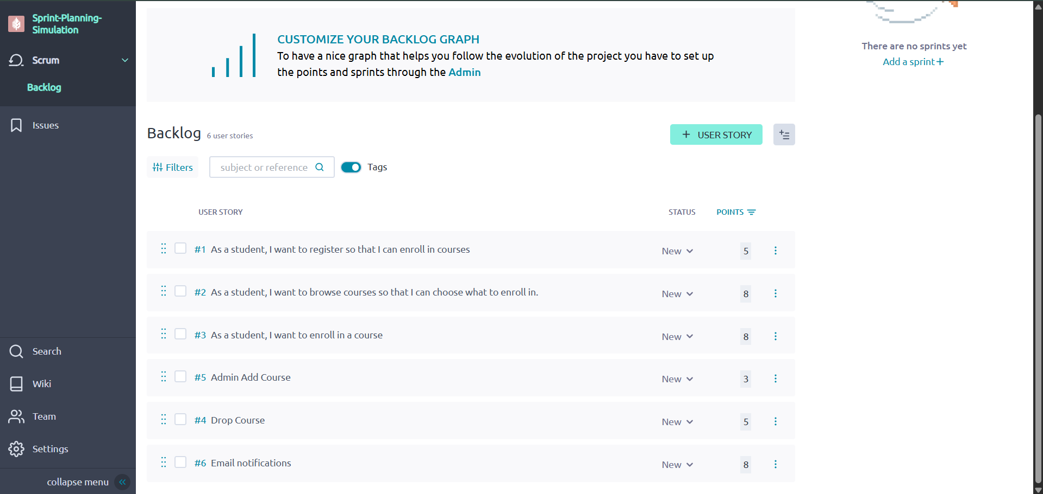

PHASE 2: SPRINT PLANNING MEETING – PART 1

Step 3: Define Sprint Goal
Enable students to independently register, browse available courses, and enroll in selected courses through the Online Course Registration System.

Step 4: Select User Stories for the Sprint
Sprint Capacity: 25 Story Points
Selected Stories for Sprint 1:
- Student Registration – 5 SP
- Browse Courses – 8 SP
- Course Enrollment – 8 SP
- Admin Add Course – 3 SP
Total = 24 SP (Within capacity)
These stories were selected because they directly support the Sprint Goal of enabling students to register and enroll in courses.
Stories not selected:
- Drop Course
- Email Notification
Reason: To avoid over commitment and protect the Sprint Goal

PHASE 3: SPRINT PLANNING MEETING – PART 2
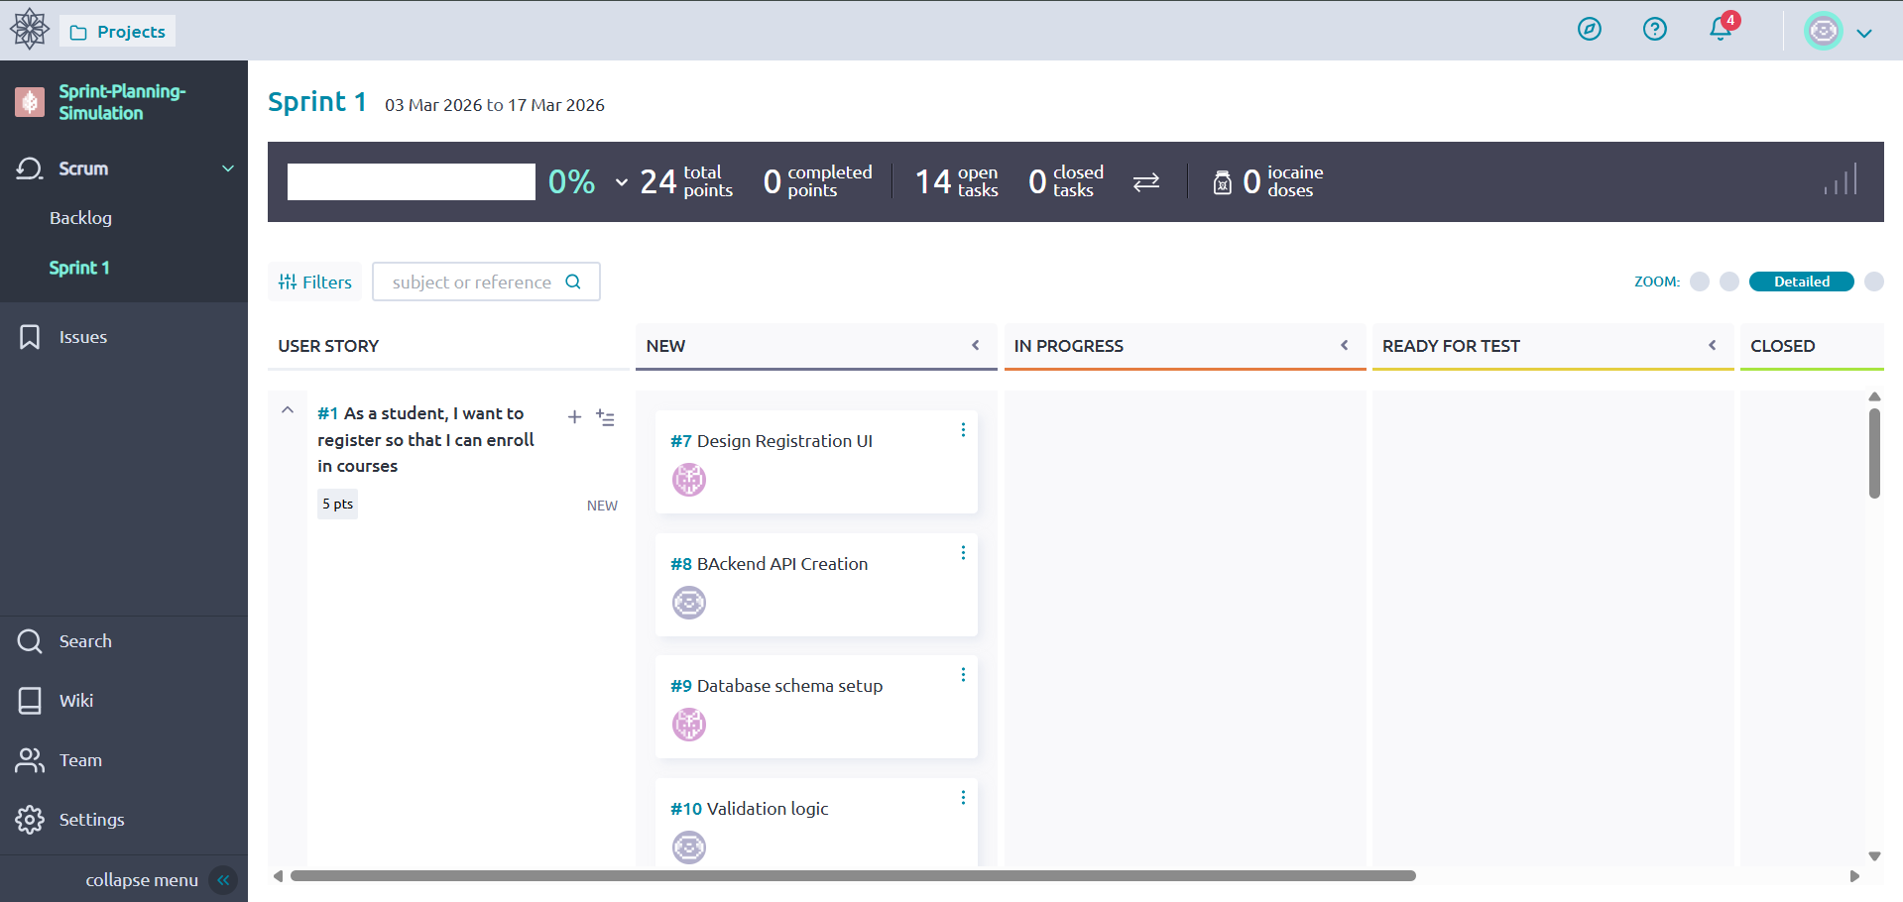
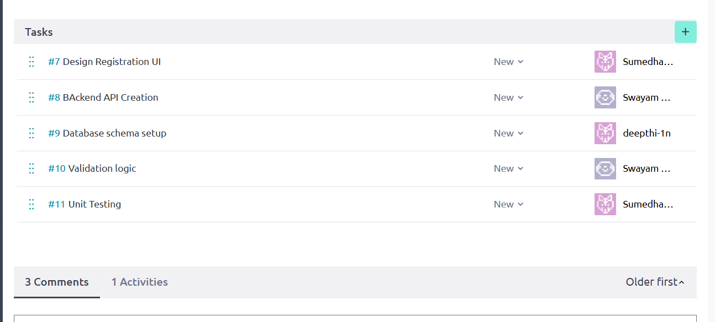
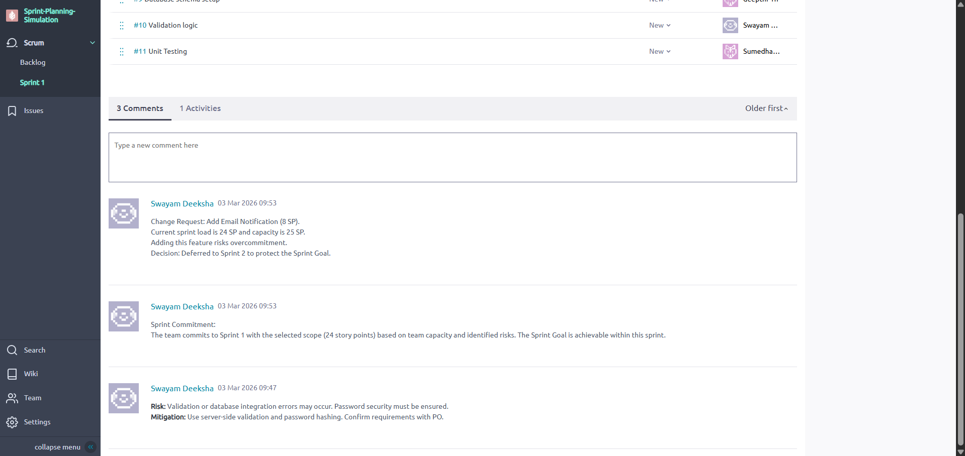
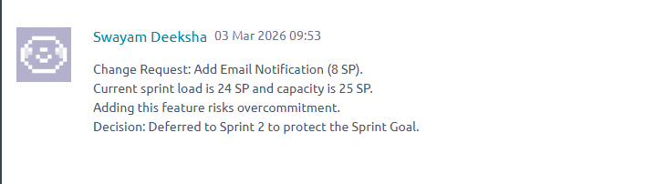

Reflection
This sprint planning simulation was a revelation and did demonstrate how capacity, priority and risk influence what we can actually commit to. We calculated that the group would be able to do approximately 25 story points, and we decided to go with 24 to make the number realistic. All the stories were broken into manageable tasks and the risks were marked with how to deal with them. When a mid-sprint change was noted, we suspended it to the next sprint so that we could not destroy the Sprint Goal. Through this exercise it became clear that sprint planning is a balancing dance of value, risk and capacity that is a team work, and is a decision making process.

